No. of Pages | 3
No. of Questions | 4

Department of Computer Science and Engineering
MIDTERM EXAMINATION Spring 2009

CSE320: Data Communications
Total Marks: 60 Time Allowed: 70 minutes
- Answer ALL Four (4) questions
- Figure in bracket [] next to each question indicates marks for that question

Question No. 1

- Match the following functions to the appropriate layers of the OSI model : [4 marks]
  - How to access the media.
  - Establishing, managing, and terminating sessions in applications
  - Bit rate and network topology consideration
  - Selection of the best path to a network.
  - Compression of video files
  - Providing independence from different data representation
  - No retransmission of data if lost.
  - Adds both header and trailer to the PDU.
- Give examples of applications, services and protocols when you email to a friend using web mail. [3 marks]
- What is the relationship between IP, TCP, Telnet, Ethernet, DNS and UDP? Draw a diagram relating the protocols and showing their position in the OSI model. [3.5 marks]
- Complete the frames shown below with appropriate addresses (Use the separate sheet provided). The sender has two applications running one for email with port number of 1029 and the other for accessing the ftp server with port number 1030. The frames shown are all intended for the ftp server. [4.5 marks]
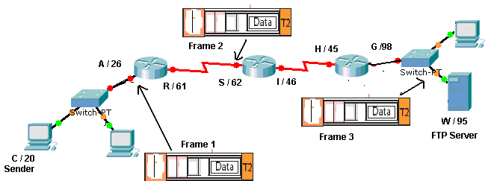

Question No. 2

- List the steps that occur after a PC in a network broadcasts a DHCP OFFER message to a DHCP server. [4 marks]
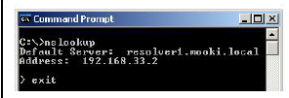
C:\>ns lookup
Default Server: resolver1.mook1.local
Address: 192.168.33.2
>exit
- Refer to the command prompt output above; the command that is shown was issued on a PC. What does the IP address 192.168.33.2 represent? Explain the purpose of that server. [4 marks]
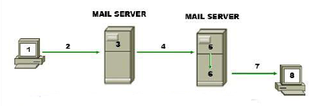
- MDA 2.MUA 3.MTA 4.SMTP 5.MTA 6.POP 7.MDA 8.MUA
Correct the above statement. What is the difference between SMTP and POP? [3 marks]
- Match appropriate protocols with the following statements: [3 marks]
- A protocol that uses GET messages to request data from a server.
- Helps you share files in your C drive with others using the Internet.
- Uses two separate connections to upload files.
- Provides encryption during a telnet session.
- Helps deliver emails to clients
- Control the secured transfer of web resources from a web server
Question No. 3

- IP is an unreliable protocol. What does this mean? What is the purpose of the time to live (TTL) field in the packet header? [4 marks]
- What is the purpose of subnet mask? Why do routers need subnet mask along with destination ip addresses? What is the difference between 255.255.255.192 and /26 notations? [5 marks]
- Given the IP address find the following information (Use the separate sheet provided): [6 marks]
IP address : 10.100.20.180
Subnet mask : 255.255.255.240
Network
Broadcast
First usable host
Last usable host
number of usable host addresses

Question No. 4

- Give an example of a type of data that cannot tolerate delay, but can tolerate some loss or data. This type of data would use which transport layer protocol? How does that protocol ensure faster transmission? [4 marks]
- A client host is requesting a web page from a server. [4 marks]
  - How does it choose the source port number to go in the segment header? And also what type of port number does it choose?
  - What type of port number will the server choose?
- When the hosts have finished exchanging application data, how many steps does it take to close the connection? Draw the process. [4 marks]
- The source host sends segments with sequence numbers 2000 to 3999. The segments with numbers 2000 to 3599 all arrive safely but the others were dropped due to congestion on the destination side. What will the destination host send in reply? [ 3 marks]

THE END

